In Jenkins users will be created and provide required permissions , Jenkins will Integrate with LDAP server in real world

LDAP will use to create user and Groups and provide required permissions

If we are Admin then only we can see Manage Jenkins option

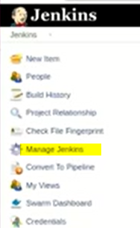

If we are normal User we will not have that option

We will give permission based on the role of the user

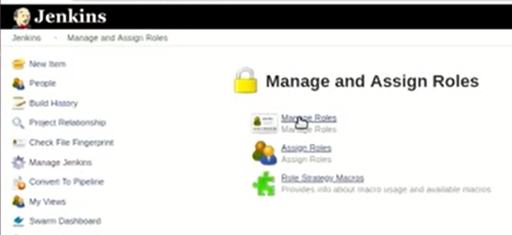

Now we are going to set permission based on Roles

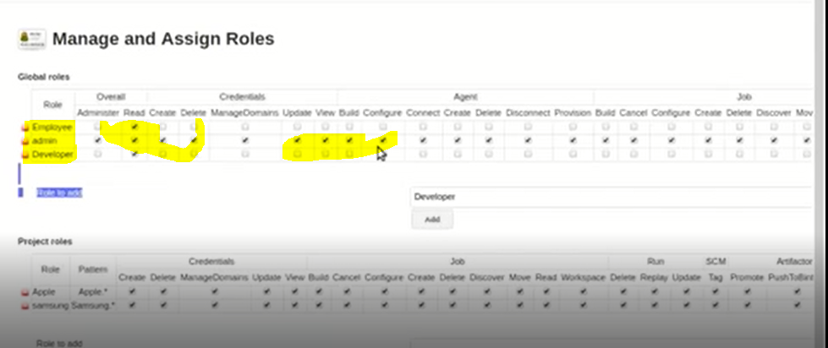

Now we are going to Assign Roles to user’s

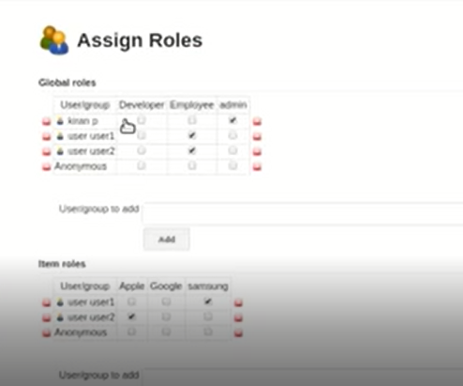

This is the way we will create Roles and Assign those to users